|  |  |  |
| --- | --- | --- |
| Data Communication and Networks | | |
|  |  |  |
| Error Detection and Correction | | |

# Prashanth.S (19MID0020)

# Aim

|  |  |
| --- | --- |
|  | To implement and manipulate the Error detection and Correction algorithms used in Networking theory using Python |

# Error Detection Methods

|  |  |
| --- | --- |
|  | 1. Single Parity |
|  | 1. 2-Dimensional Parity |
|  | 1. Check-Sum |
|  | 1. Cyclic Redundancy Check |

# 1)Single Parity

# 

# Analysis

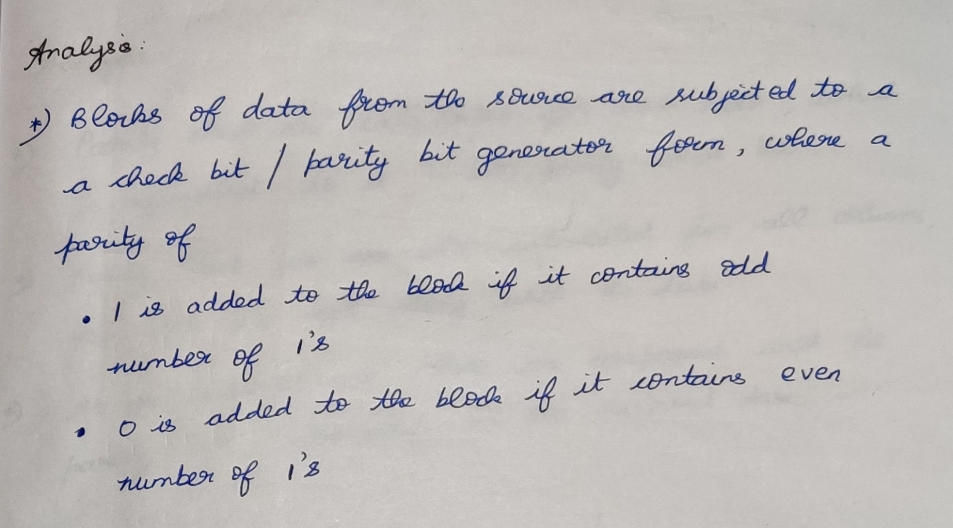

# Flow-chart

# Code Structure

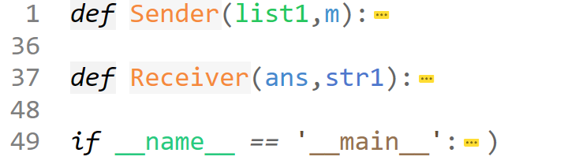

# Actual code

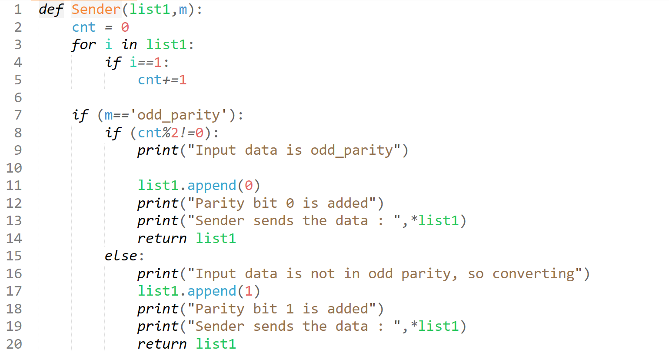  
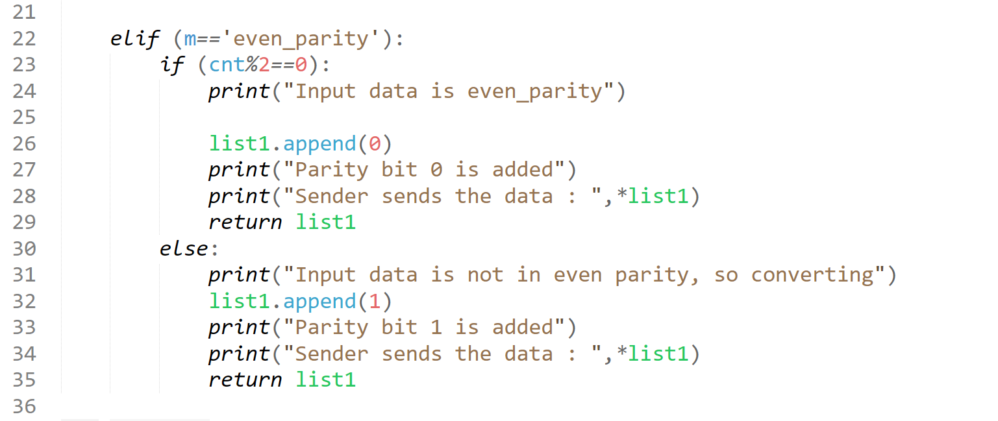

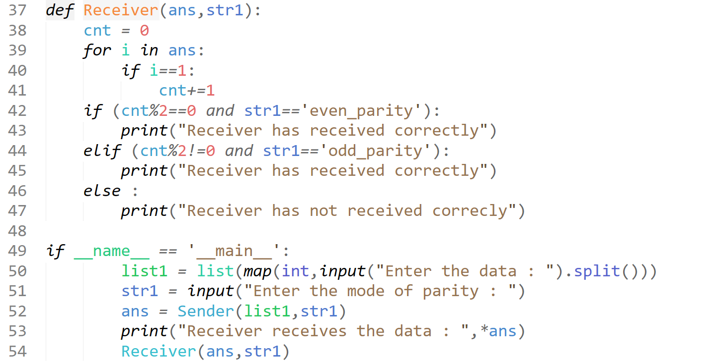

# Test-case-1

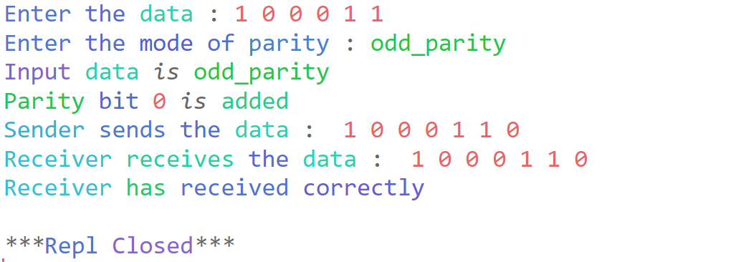

# Test-case-2

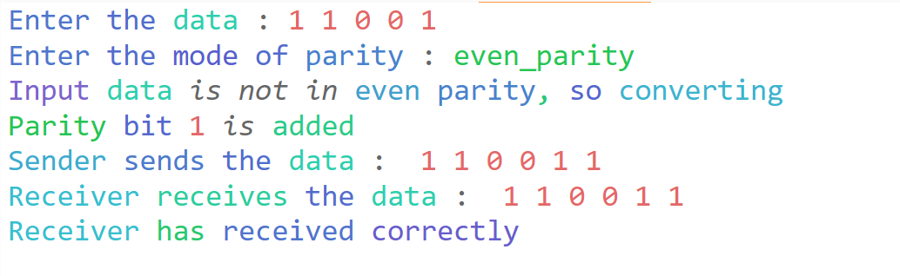

# Output

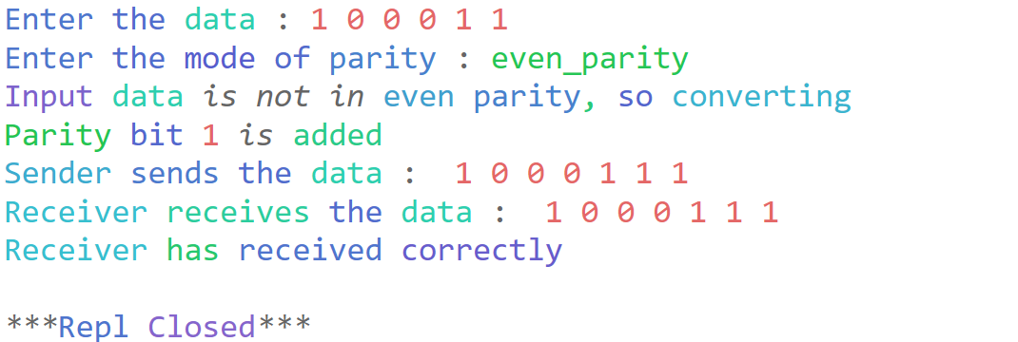

# 2) Two-Dimensional Parity

|  |
| --- |
|  |

# Analysis

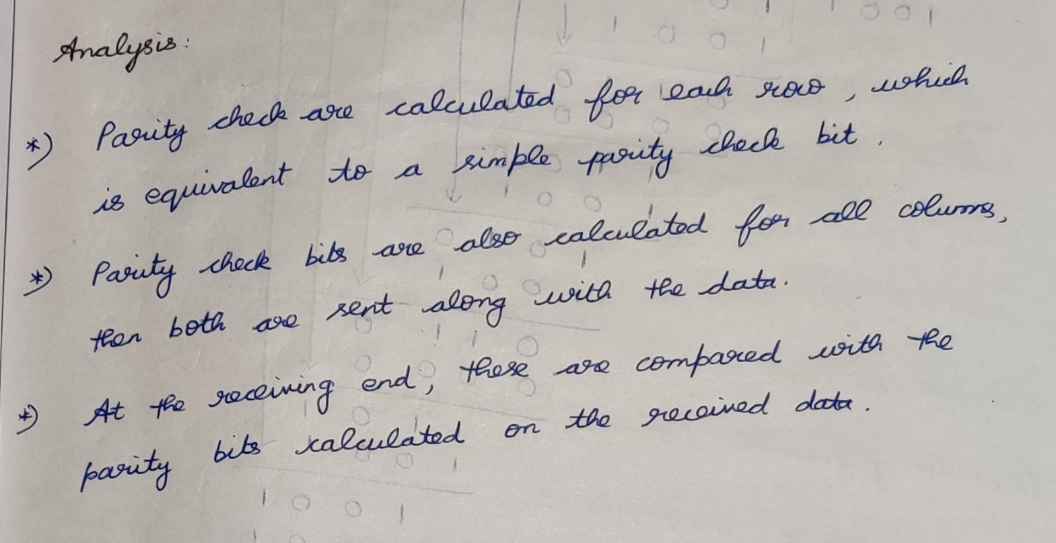

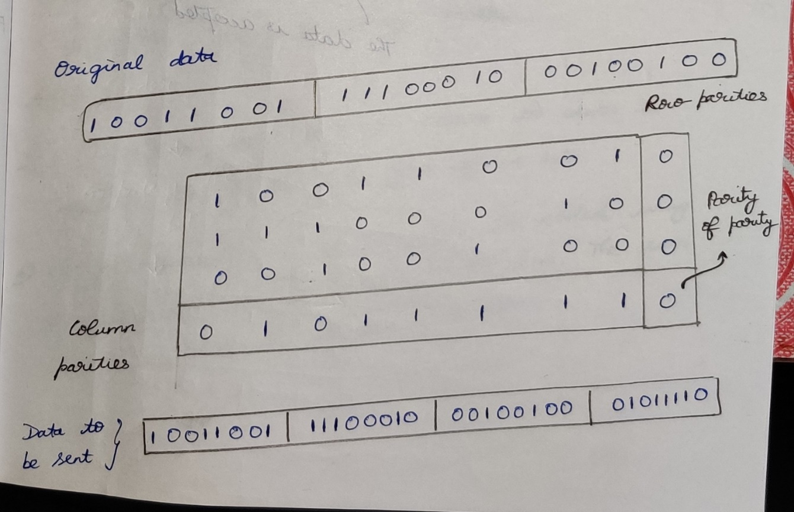

# Flowchart

|  |
| --- |
|  |

# Code-structure

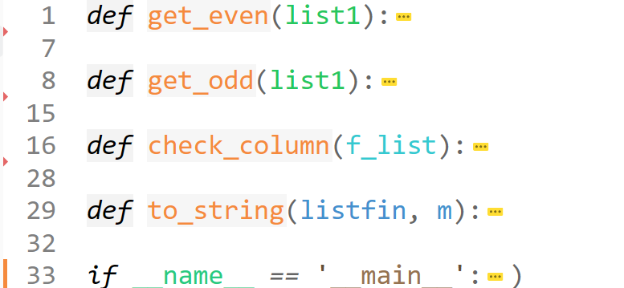

# Actual-Code

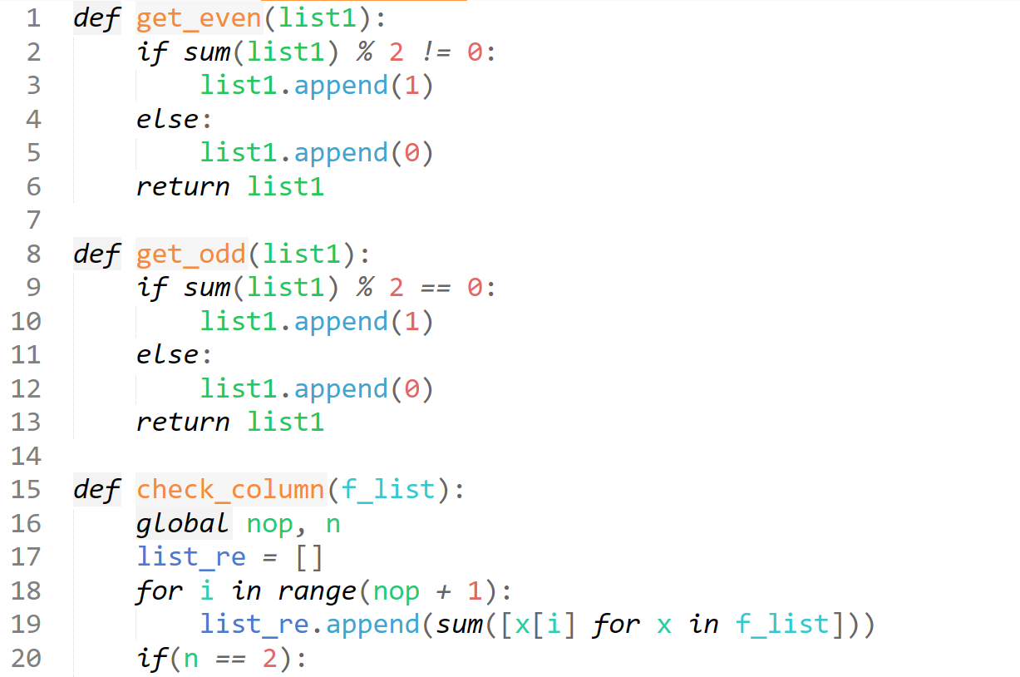

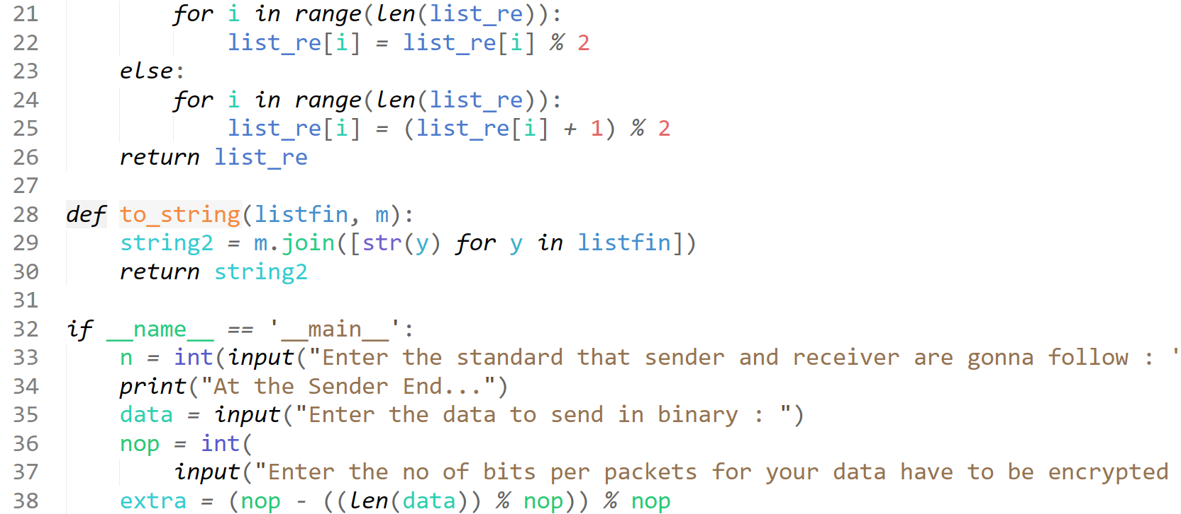

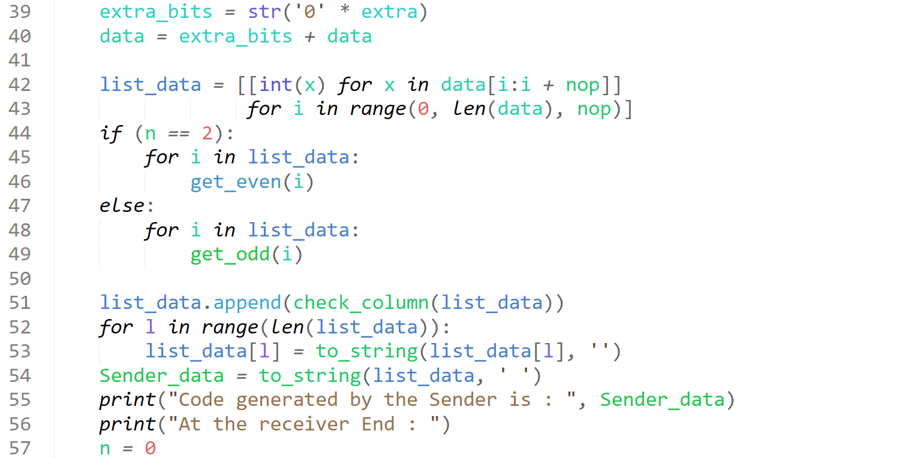

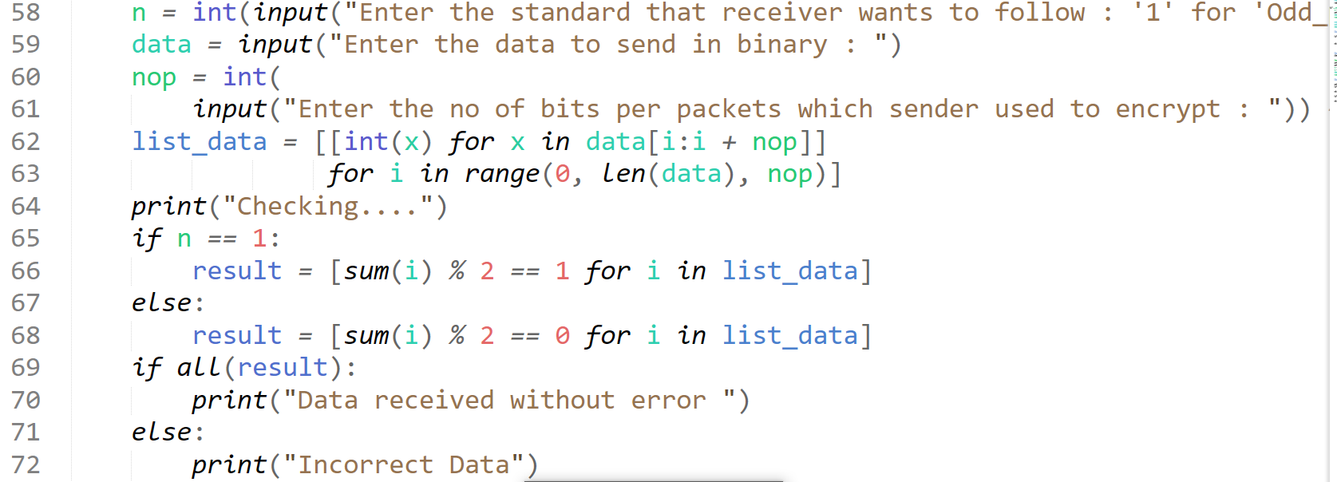

# Test-case-1

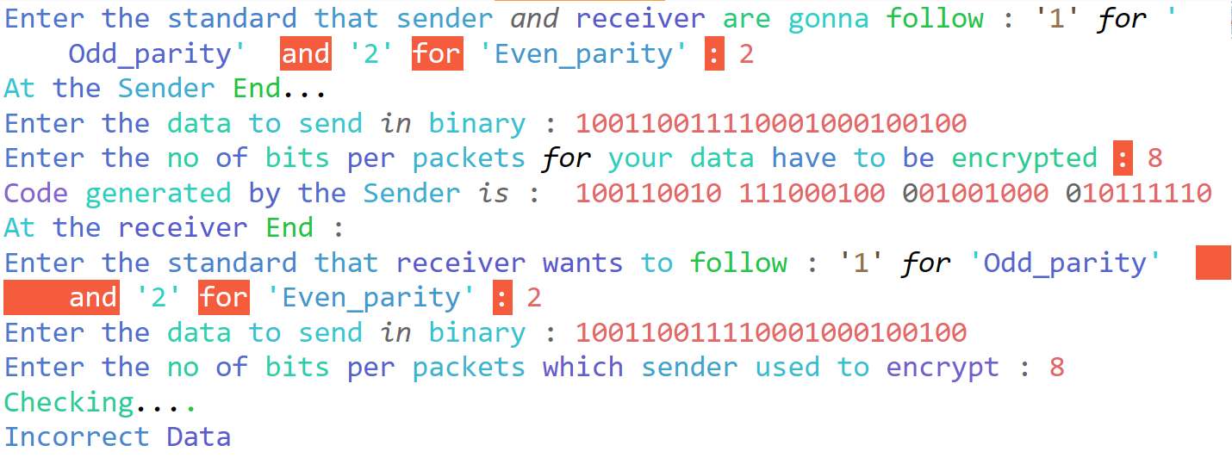

# Test-case-2

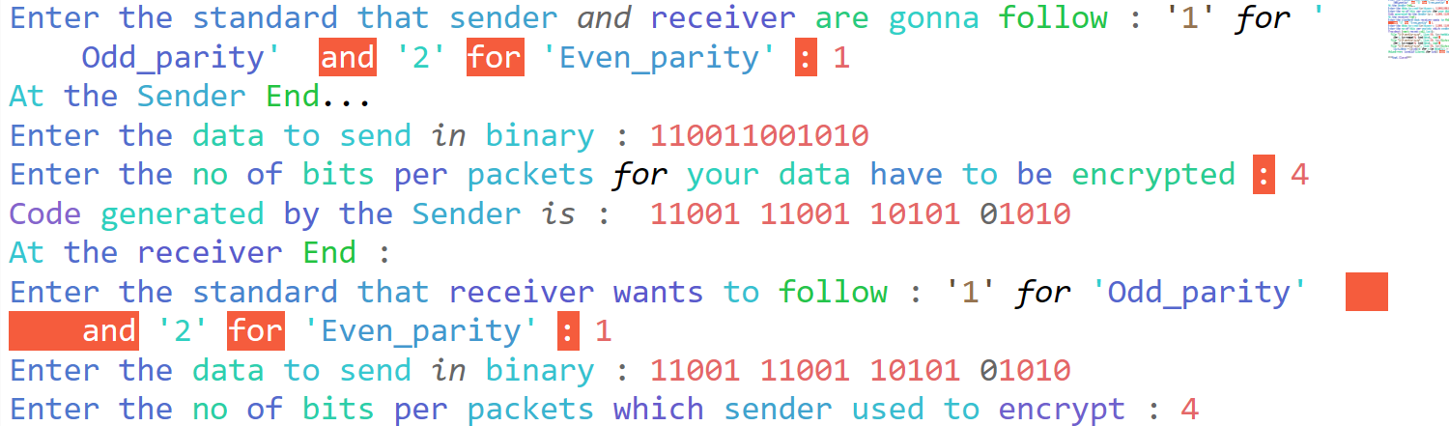

# Output

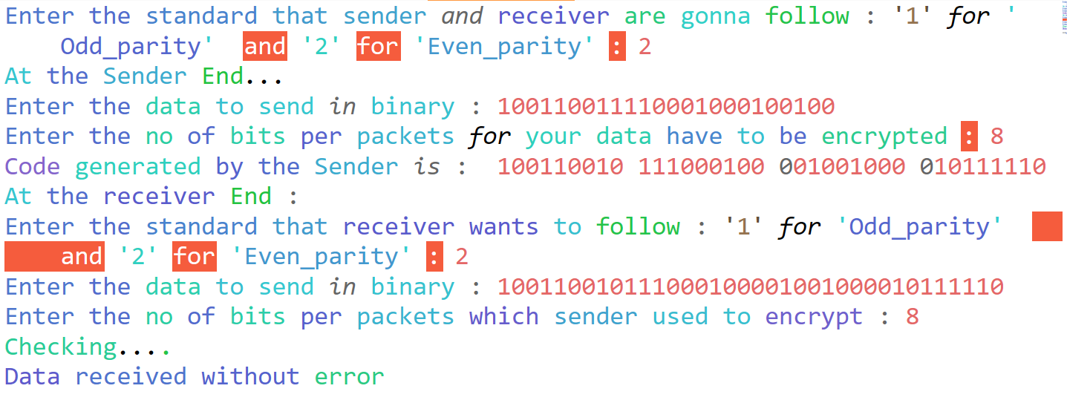

# 3)Checksum

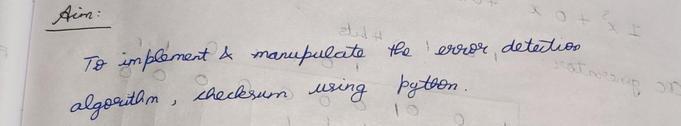

# Analysis

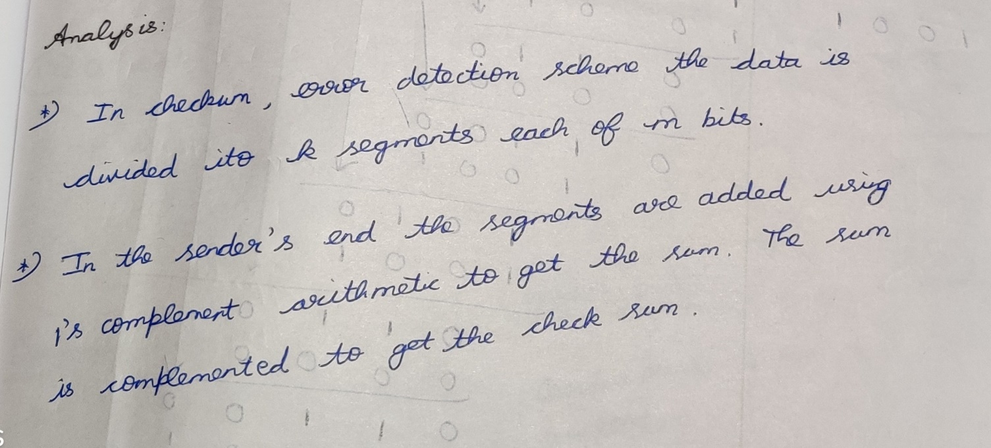

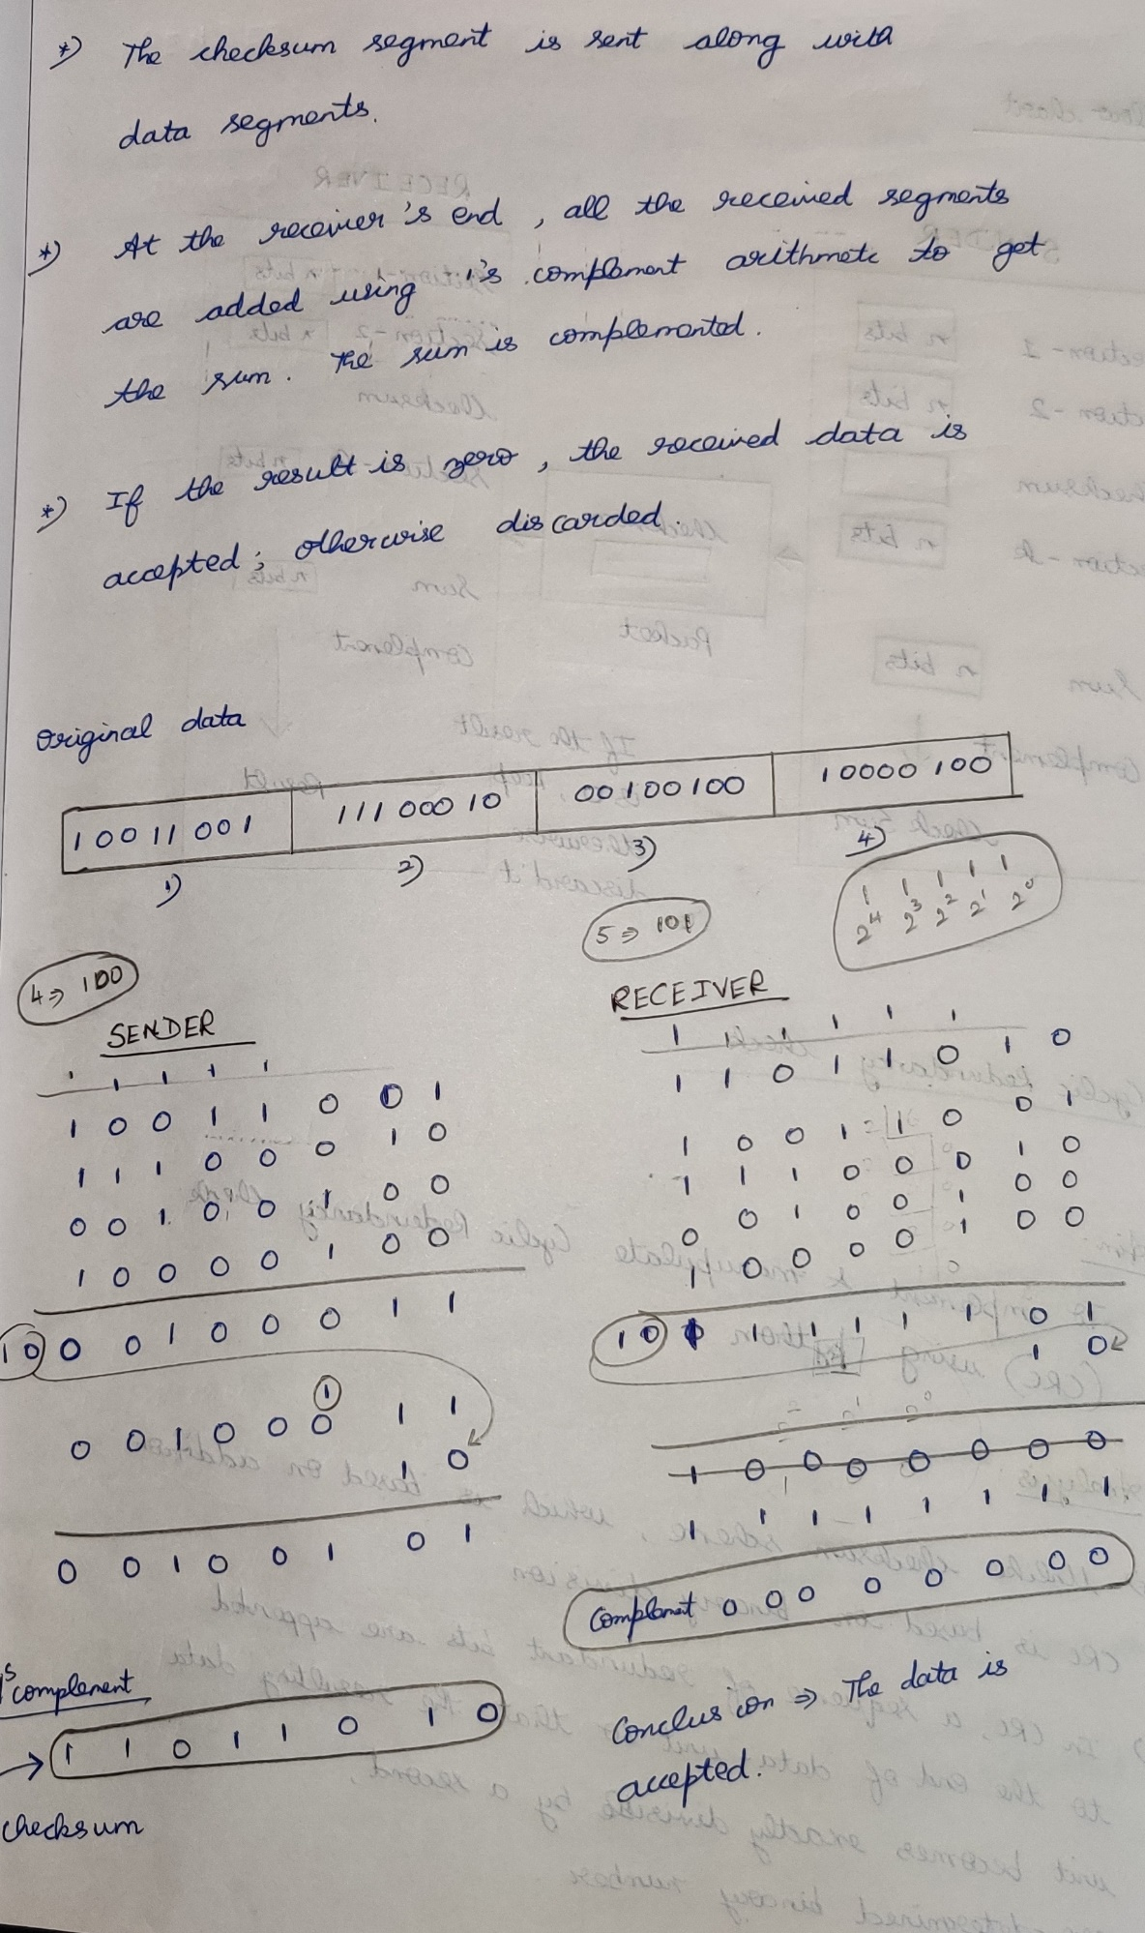

# Flowchart

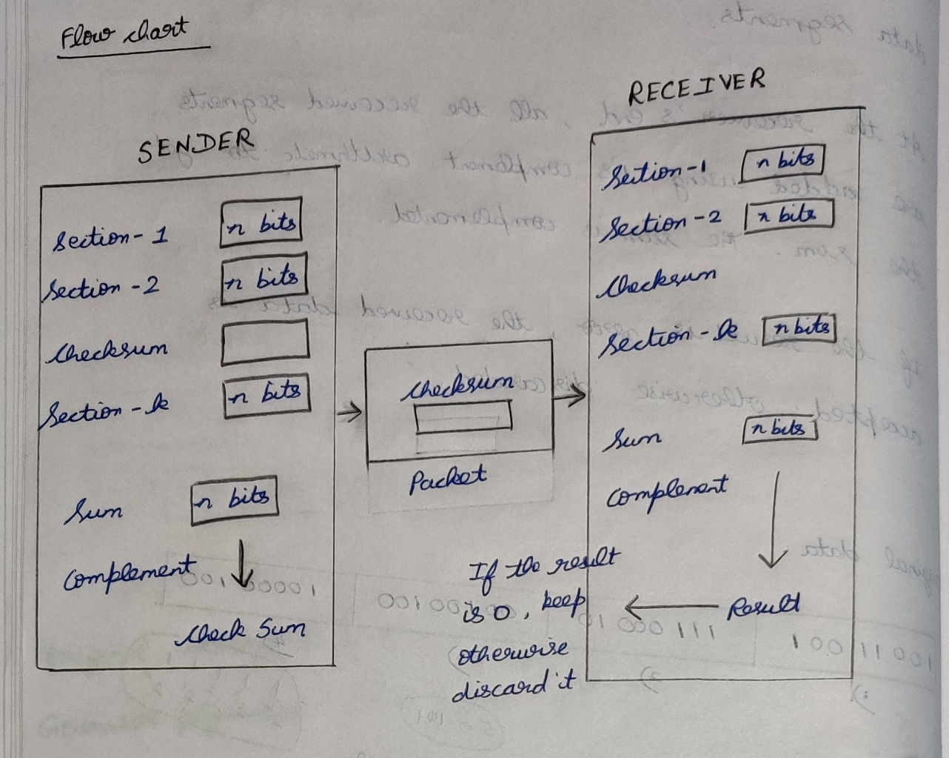

# Code-structure

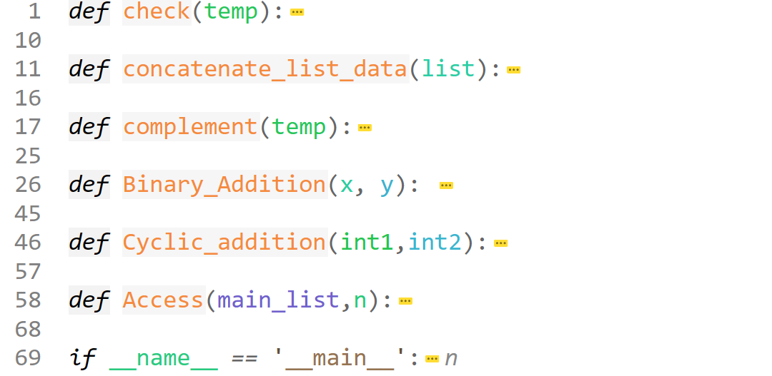

# Actual-code

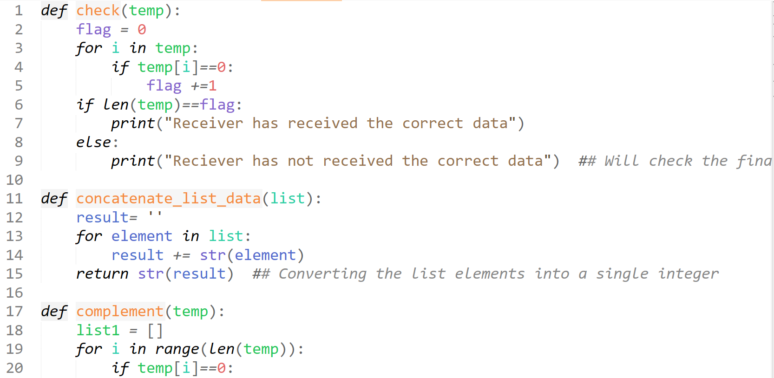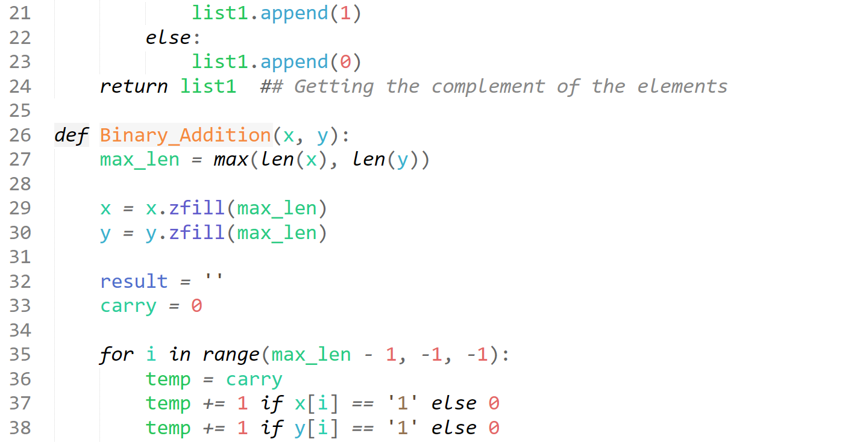

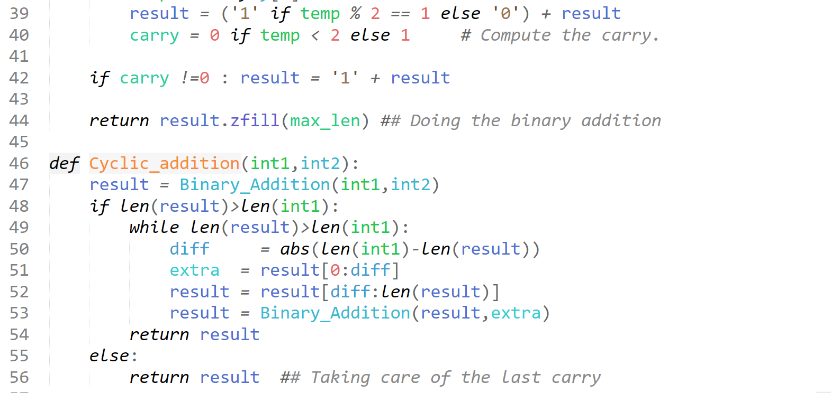

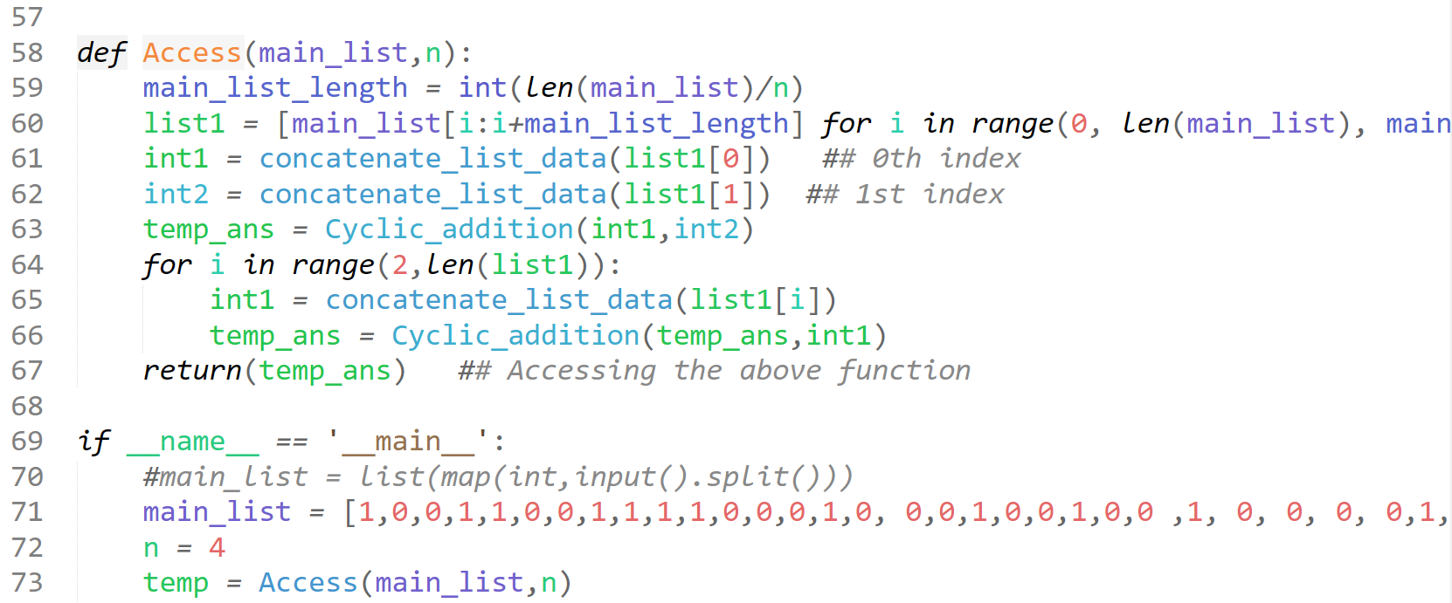

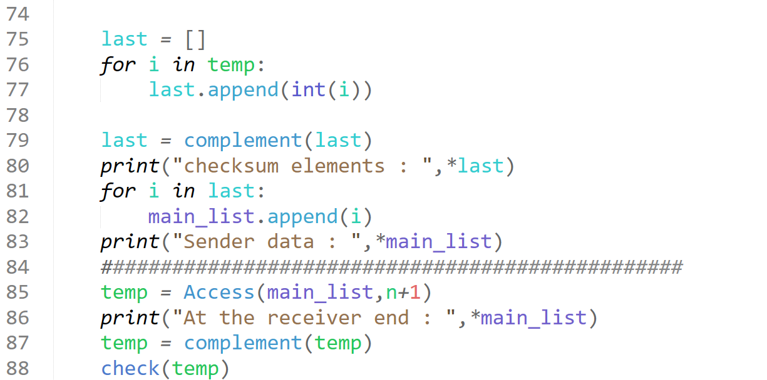

# Test-case-1

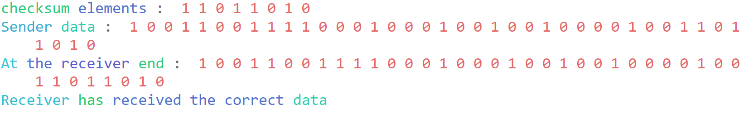

# Output

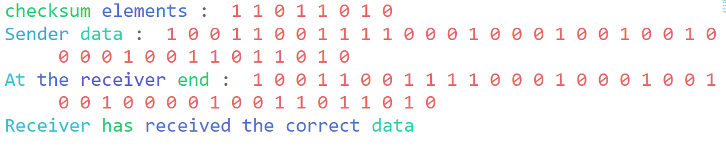

# 4)Cyclic Redundancy Check

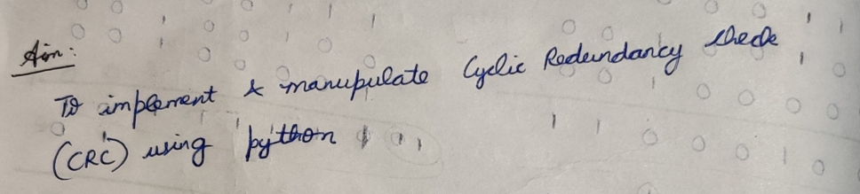

# Analysis

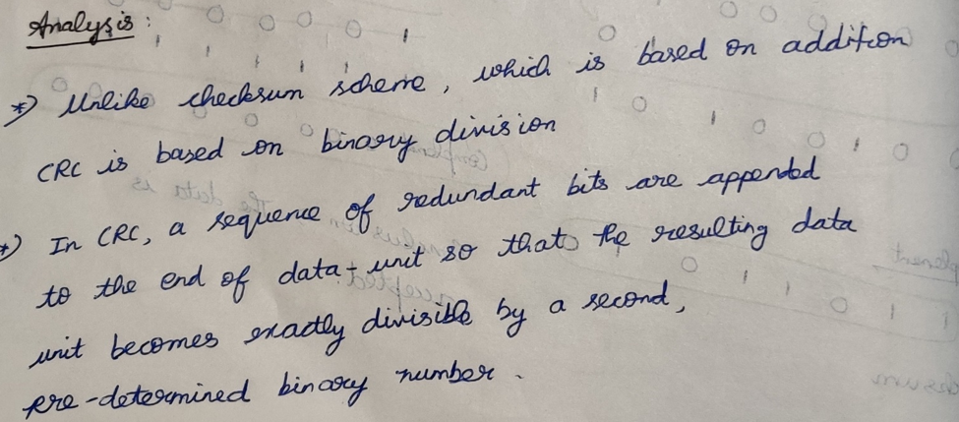

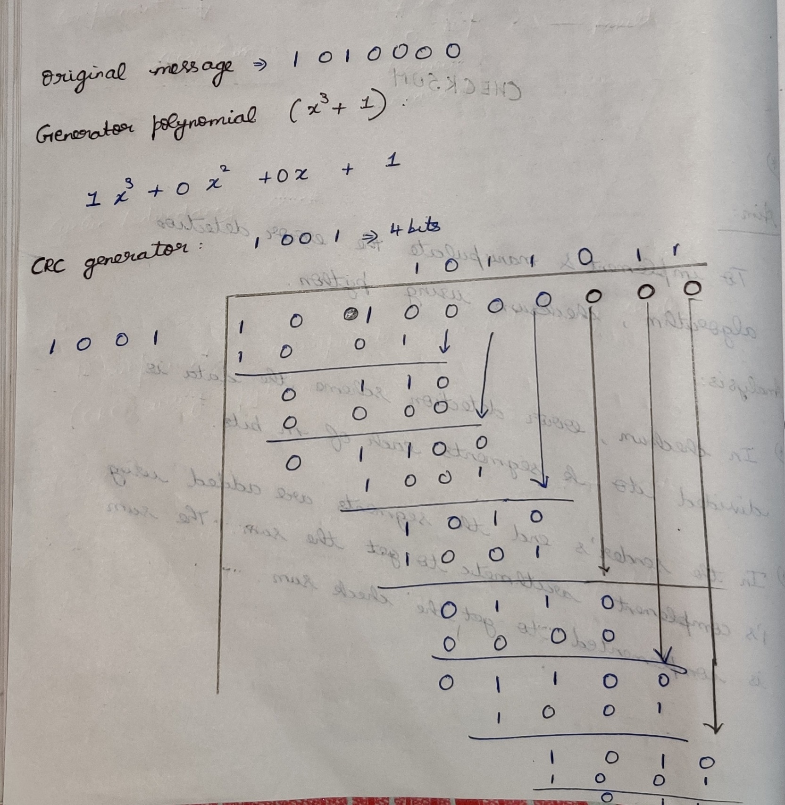

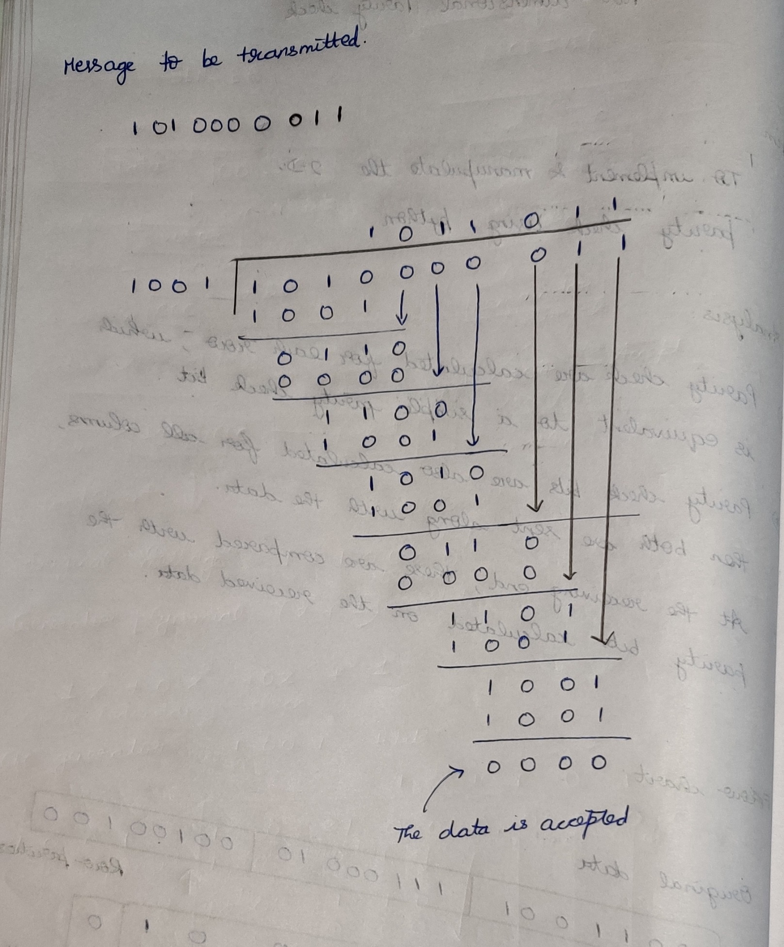

# Flow-chart

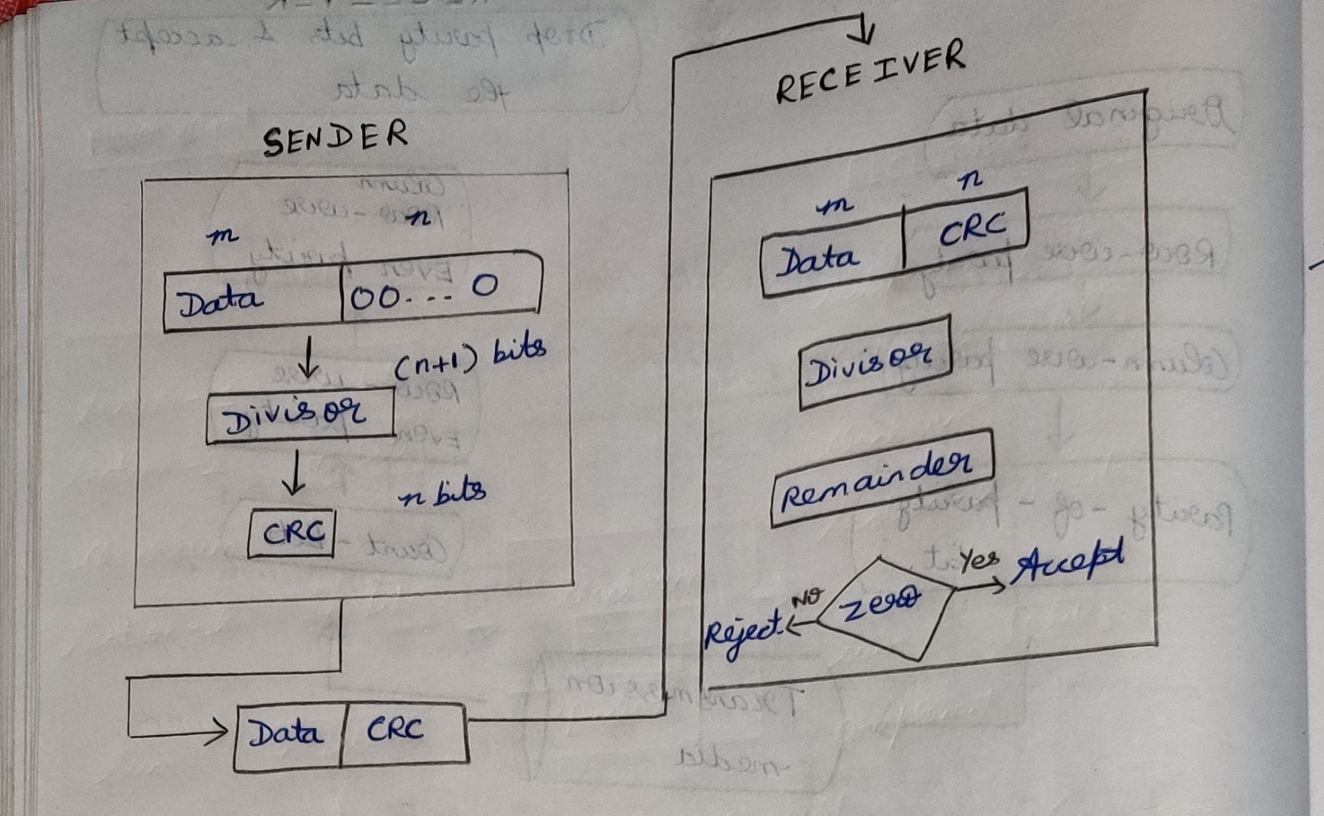

# Code-structure

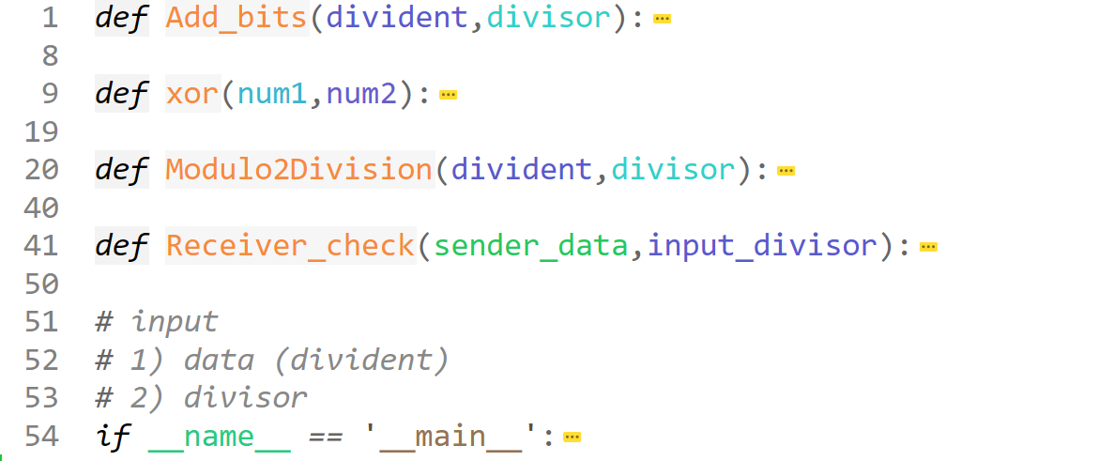

# Code

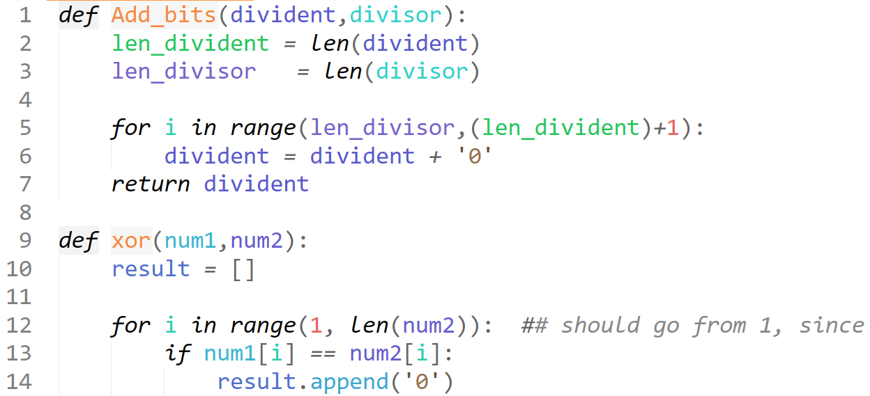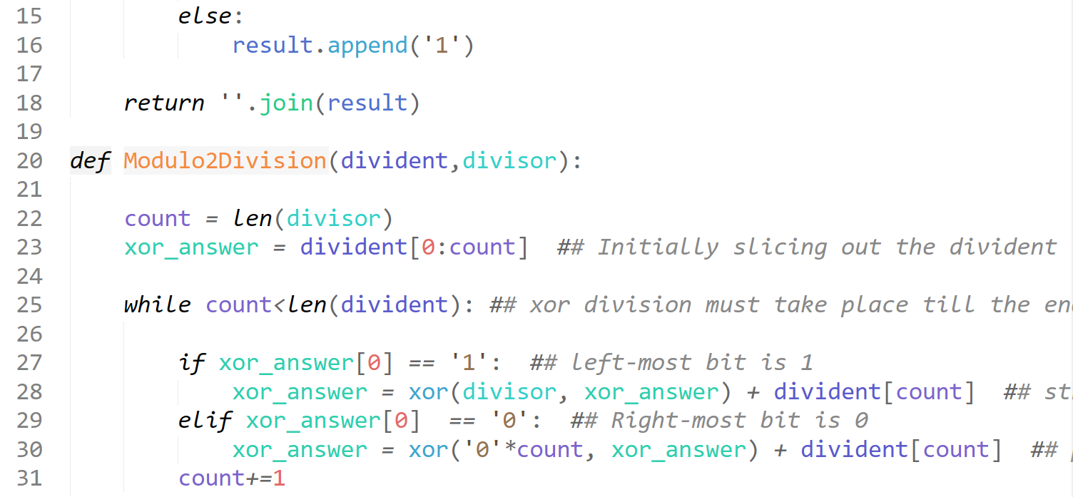

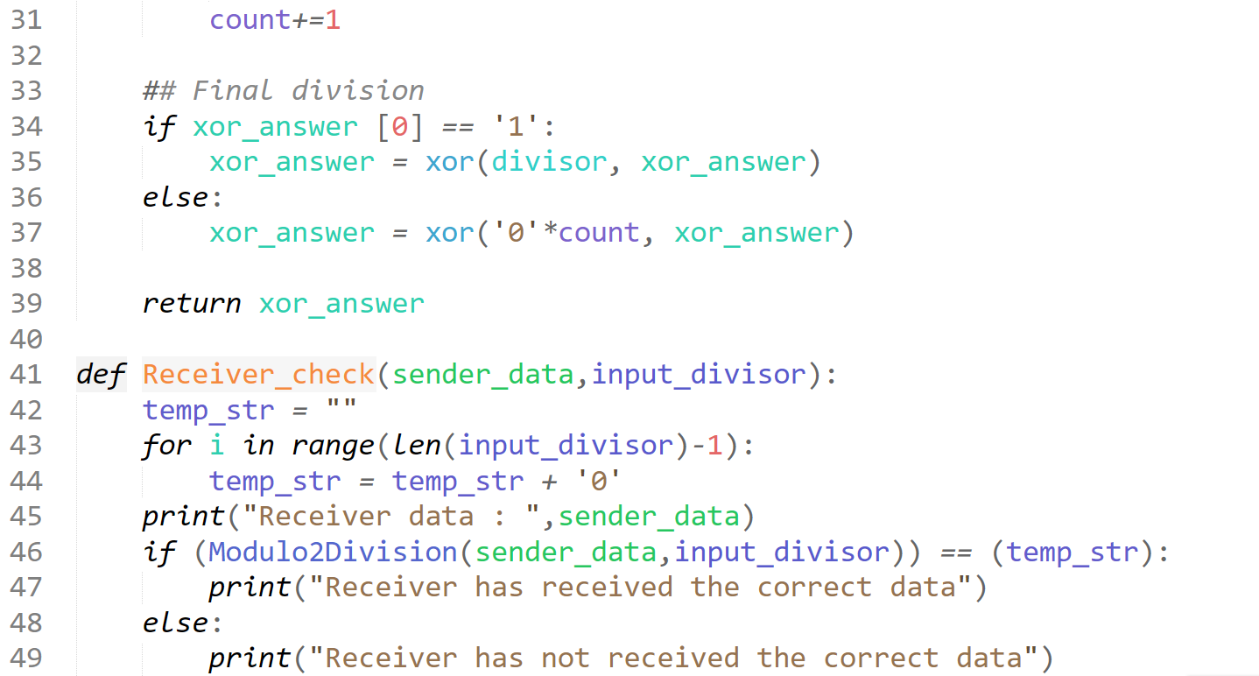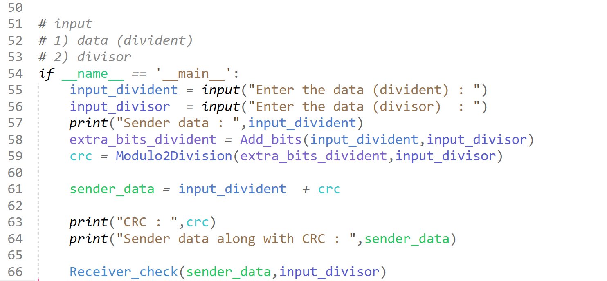

# Test-case-1

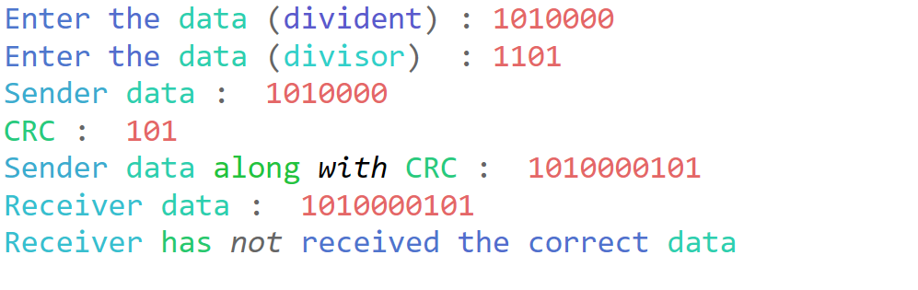

# Test-case-2

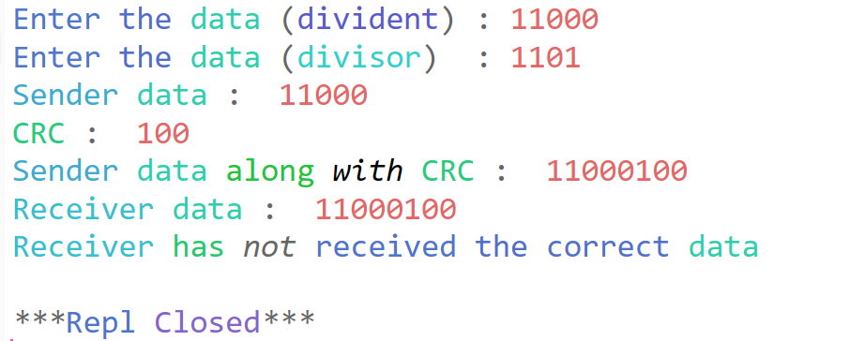

# Result

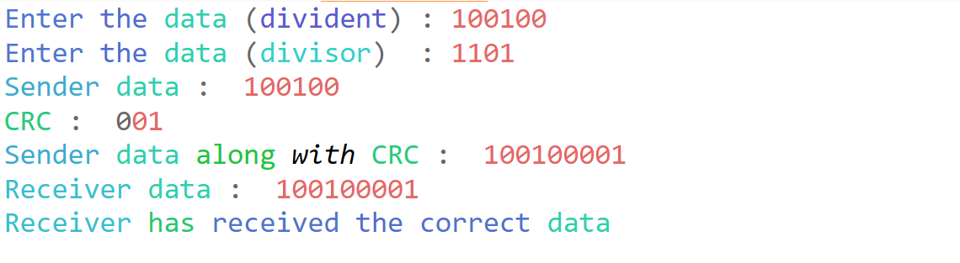

**Sir, the above program code are also available in my github,** [**https://github.com/PrashanthSingaravelan/WinterSemester-2021/tree/main/CSI2007%20Data%20Communication%20and%20Network/Lab%20Assignment/Assignment-2**](https://github.com/PrashanthSingaravelan/WinterSemester-2021/tree/main/CSI2007%20Data%20Communication%20and%20Network/Lab%20Assignment/Assignment-2)